The Triunity of God

- Triunity = God eternally exists in three persons: Father, Son, and Holy Spirit.

Five Reasons Clarity is Important

  - See Nicene Creed (AD 325)

- We believe in the Trinity because of _______________ not _______________ (Deut 29:29).
  - Who created the world?
  - Who raised Jesus from the dead?

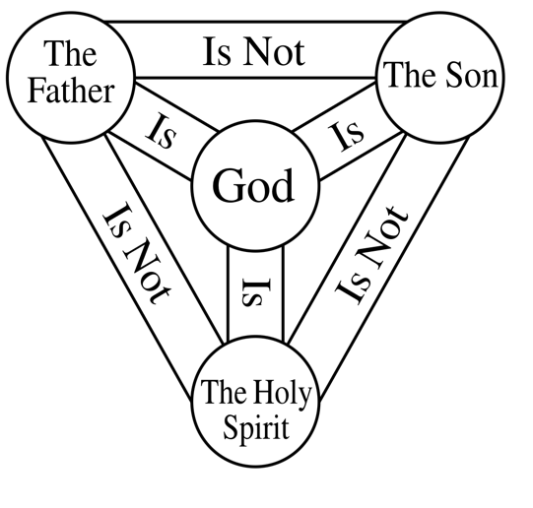
The Oneness of God: Monotheism

Plurality of Persons
- OT —
- NT —

- Each Person is ________ and ________ God.

